



**Disclaimer: The content is curated from online/offline resources and used for educational purpose only**

**LAB MANUAL**

**Unit V – Deep Learning**

**Unit V – Deep Learning**

**Lab 1. Implementation of Neural Network concepts**

**Objective**

* Build and train a Feedforward Neural Network (FNN) using TensorFlow/Keras for predicting crop yield.
* Train the neural network on the dataset to learn patterns and relationships between environmental factors and crop yield.

**Problem**

The objective of this project is to develop a Artificial Neural Network (ANN) model to predict crop yield based on various environmental and agricultural factors. These factors include temperature, humidity, rainfall, soil quality, and fertilizer used. This model can assist in agricultural decision-making, helping farmers to forecast crop yields more accurately, optimize farming practices, and plan better for future harvests.

**Solution**

we'll go through the following steps:

1. Install Required Libraries
2. Feature Selection
3. Normalize the data
4. Split the data into training and testing sets
5. Build the ANN model
6. Compile the model
7. Train the model
8. Evaluate the model

**Procedures**

1. Install Required Libraries

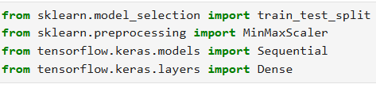

1. Feature Selection

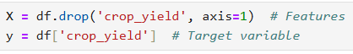

1. Normalize the data



1. Split the data into training and testing sets



1. Build the ANN model

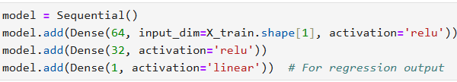

1. Compile the model



1. Train the model

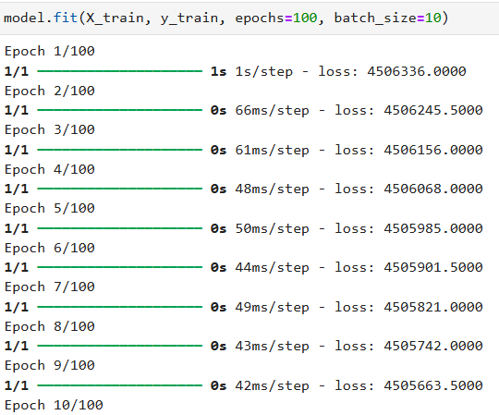

Running until 100th epoch.

1. Evaluate the model

